6 Thinking Hats

White hat - Facts  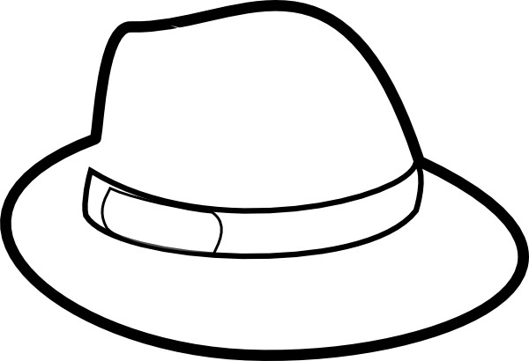 | What are conflicts?
Red hat - Emotion   | How do you feel conflicts that you see?
Black hat - Critical  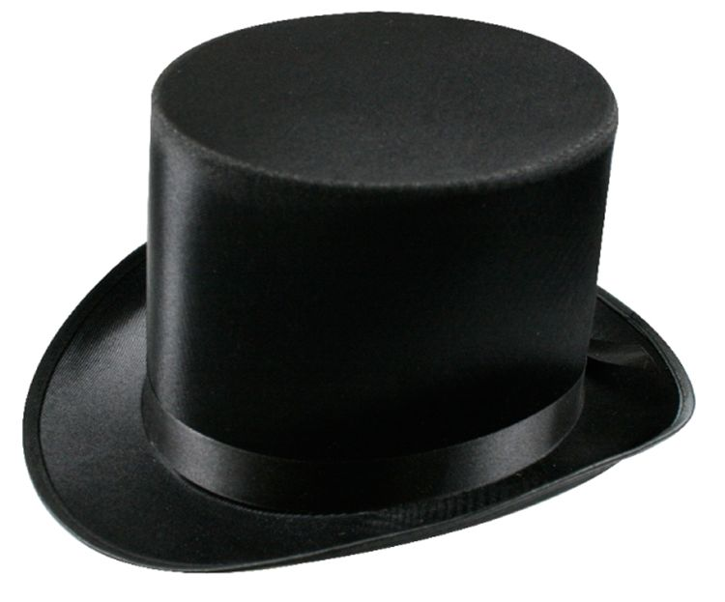 | What possible problems can conflicts cause?  What were some of the difficulties victims of conflicts would have to face?
Green hat - Creativity  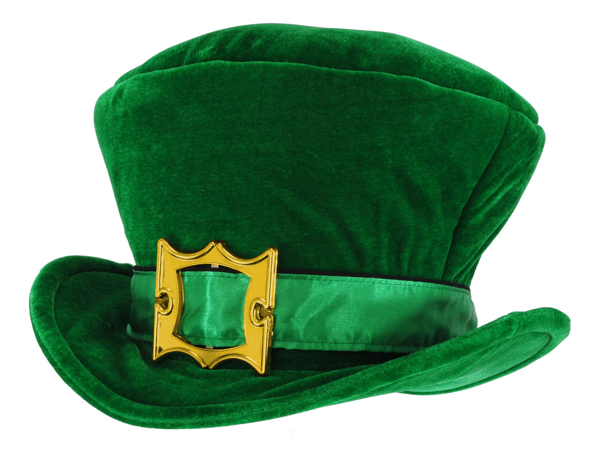 | How can these possible conflicts be resolved?
Yellow hat - Benefits   | What are the benefits of co-operation?
Blue hat - Thinking  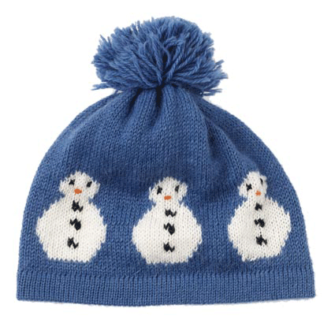 | What have you learnt from this activity?

