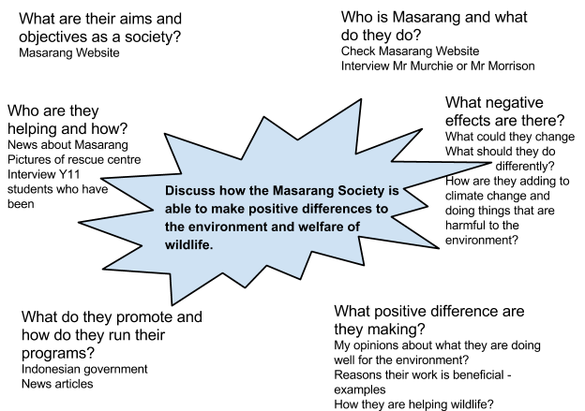

Where am I going to find information?
- News websites
- Masarang home page
- Teachers and students that have been there
- Indonesian government and forestry sights
- National Geographic
- School databases
- School library

