Create your Action Plan for research and essay plan using the mind map below. Use the 6 universal questions for your investigations.

What? Where? When?

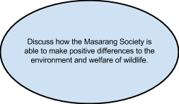

How? Why? Who?

