Locating a car factory in Brazil
Activity sheet
Personnel Manager

In this part, you are looking for:
- Cheap labour
- An educated workforce

PART 1 Data Gathering:

- Complete the Excel table for the population density.
You need to find out the population and area (km2) of each state and region of Brazil.

Use the following website to help you to complete the table:
1. Click here to select the state
http://www.ibge.gov.br/estadosat/perfil.php?sigla=ro

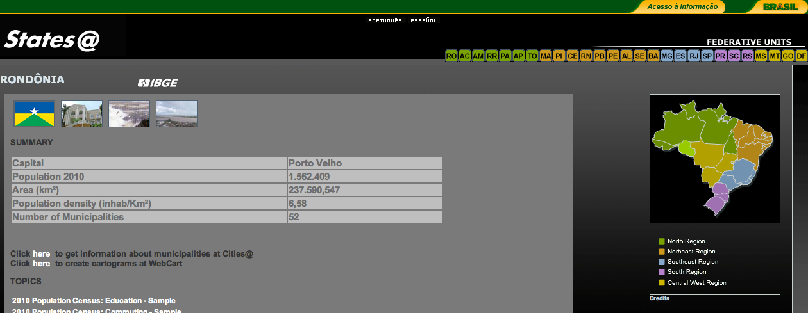
2. Find the population number here
3. Find the area (Km2) here

- Complete the Excel table for the literacy rate of each state and region of Brazil.

Use the following website to help you to complete the table:
http://www.ibge.gov.br/estadosat/perfil.php?sigla=ro
1. Click here to select the state

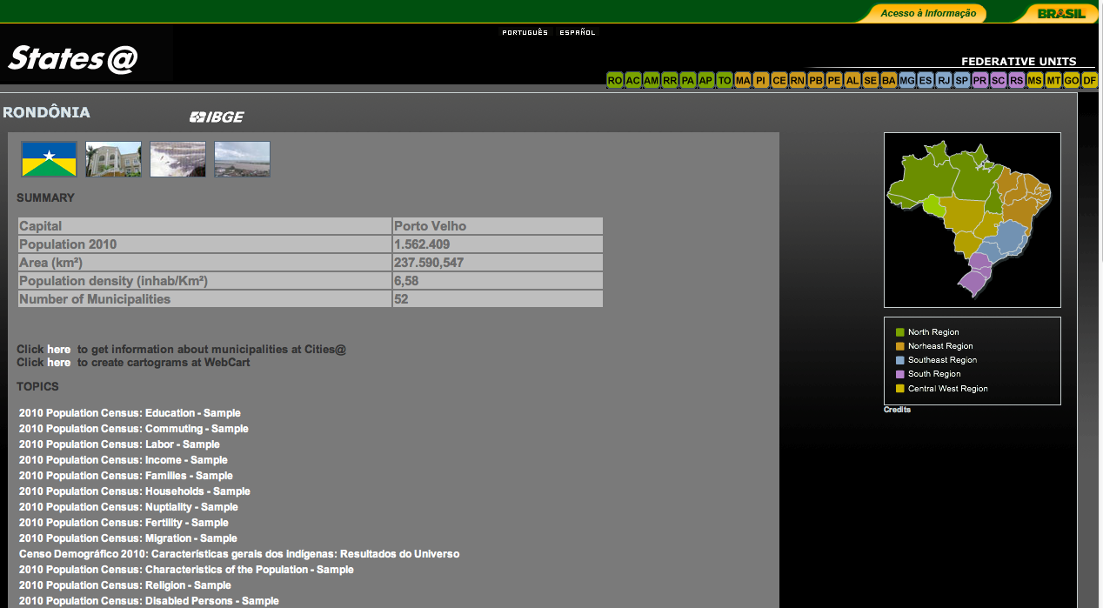
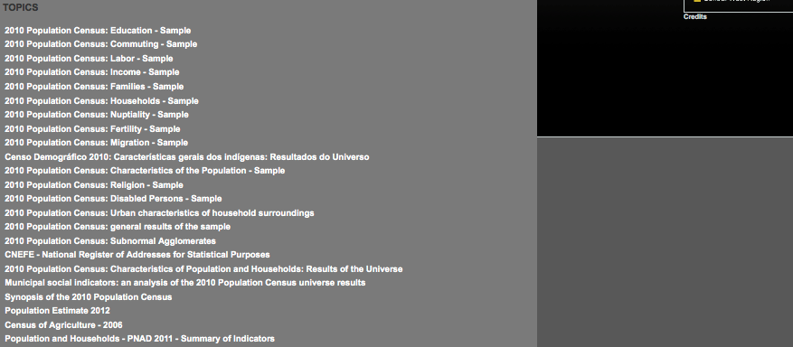

2. Scroll down the page.

3. Click on ‘Population and Households - PNAD 2011 - Summary of Indicators”

PART 2 Create 3-D bar chart:
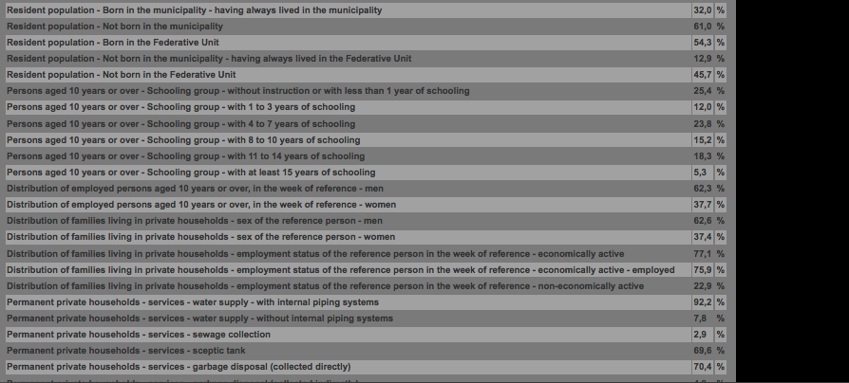
Use excel to create a 3-D bar chart to show you findings:
4. Look at “Persons aged 10 years or over - Schooling group - with 11 to 14 years of schooling”
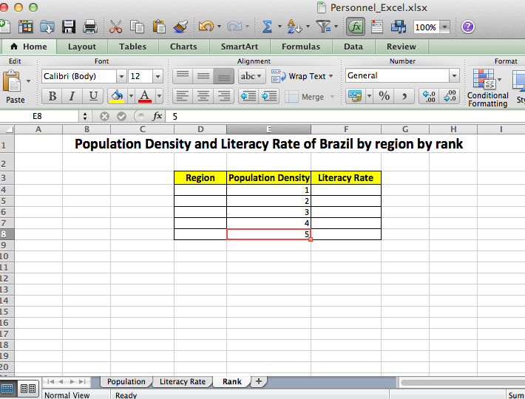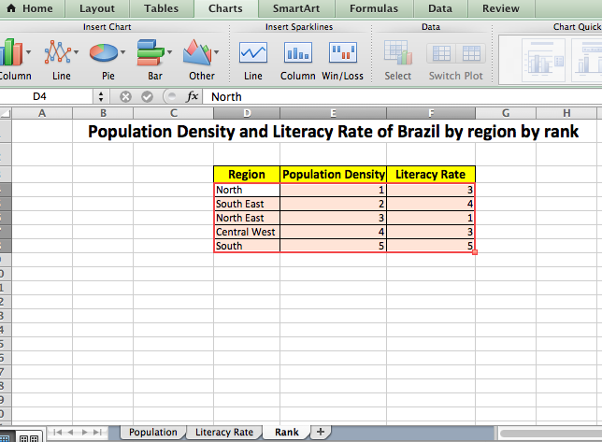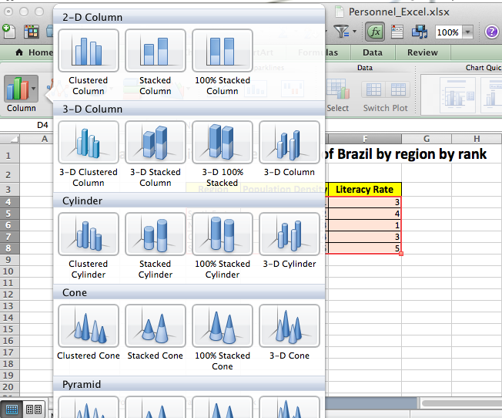
2. Go to Literacy Rate page to find out the ranking of literacy rate of different regions
1. Go to Population page to find out the ranking of population density of different regions
3. Select ALL data
4. Click “Charts “ and select “3-D Column”
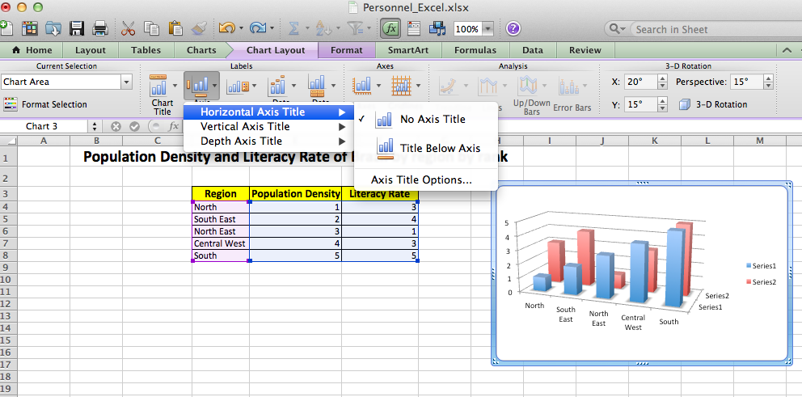
5. Go to “Chart Layout”, Click “Axis Titles” and choose “Horizontal Axis Title” then select “Title Below Axis”

6. Click “Vertical Axis Title” then select “Rotated Title”

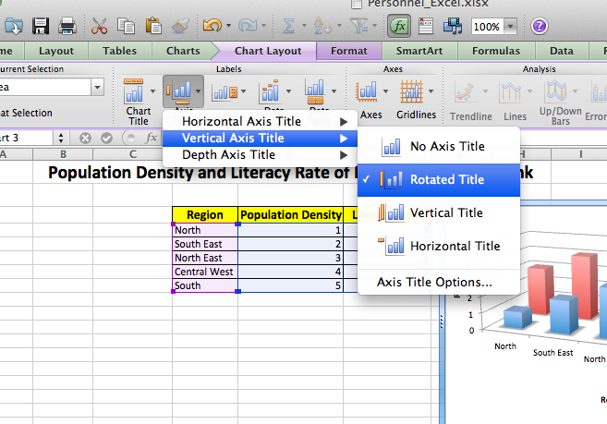

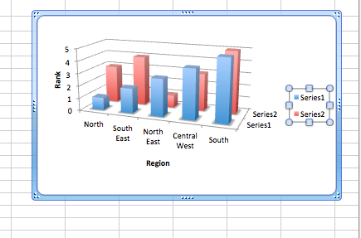
7. Change the titles to Rank and Region

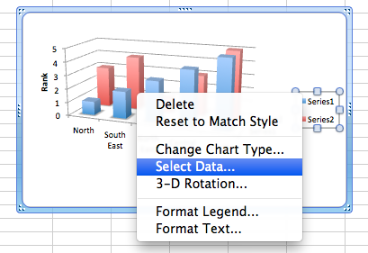

8. Right click series box and choose “Select Data”

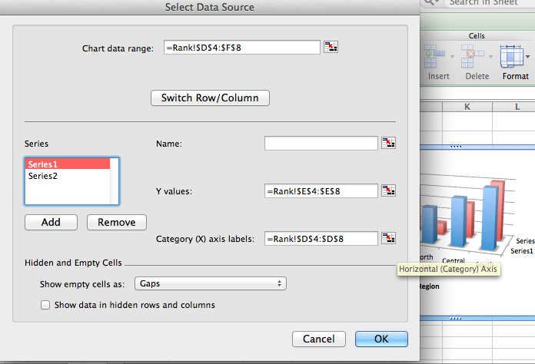

9. Select “Series 1” and Put “Population Density” in the name box.
Then, select “Series 2” and Put “Literacy Rate” in the name box.

Final Product
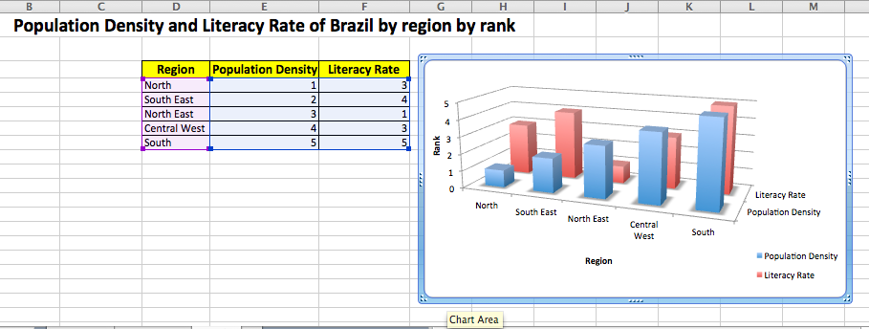
PART 3 Data Analysis
As Personnel Manager you are looking for a region with lots of cheap and educated labour.
- What is population density?
_______________________________________________________________________________________

- “The higher the population density the cheaper the labour.”
Why do you think this is?

________________________________________________________________________________________
________________________________________________________________________________________
- Which region has the highest population density?
________________________________________________________________________________________
- What is literacy rate?
________________________________________________________________________________________
- Which region has the highest literacy rate?
________________________________________________________________________________________

- Look at your 3-D chart, which region has the most balanced data?
________________________________________________________________________________________
- As a personnel manager, I would choose the following region to build the factory… (Briefly explain your answer)
________________________________________________________________________________________
________________________________________________________________________________________

