Locating a car factory in Brazil
Activity sheet

Sales manager

- Complete the table for the population of each state and region of Brazil.

Use the following website to help you to complete the table:
Click here to select the state
http://www.ibge.gov.br/estadosat/perfil.php?sigla=ro

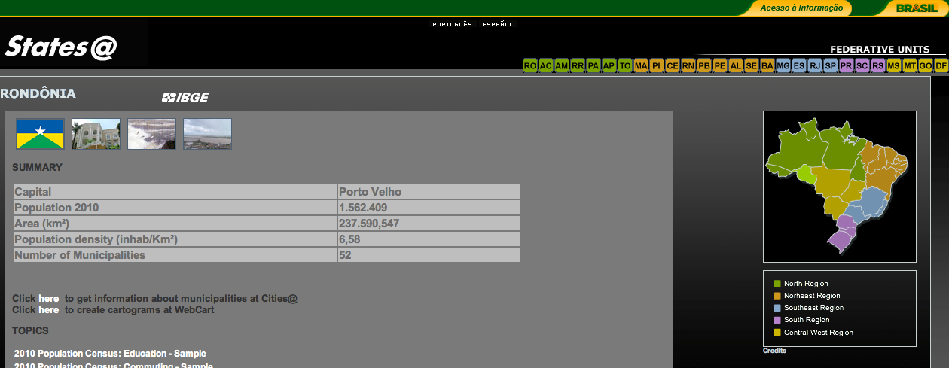
Find the area (Km2) here
Find the population number here

- Complete the table for the percentage (%) of the total income that each state contributes.

Use the following website to help you to complete the table:
http://www.ibge.gov.br/estadosat/perfil.php?sigla=ro

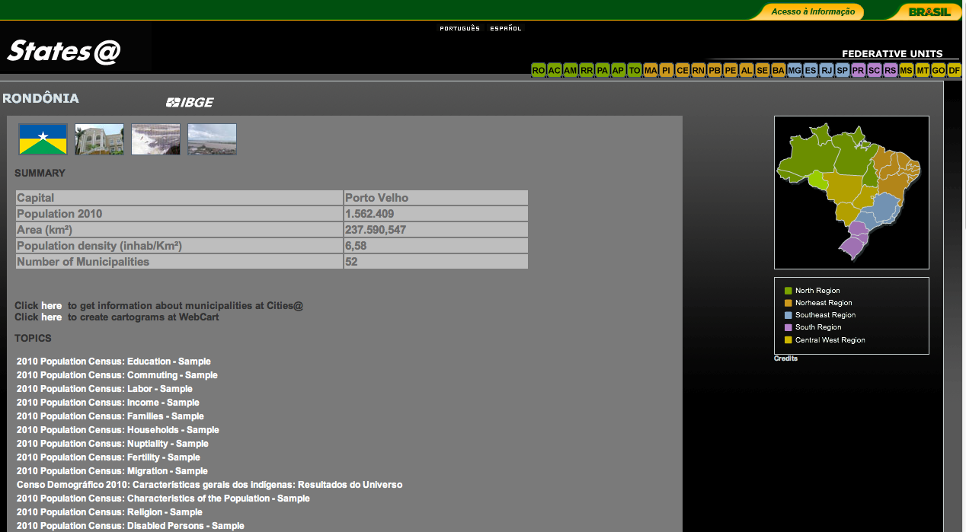
Scroll down the page.

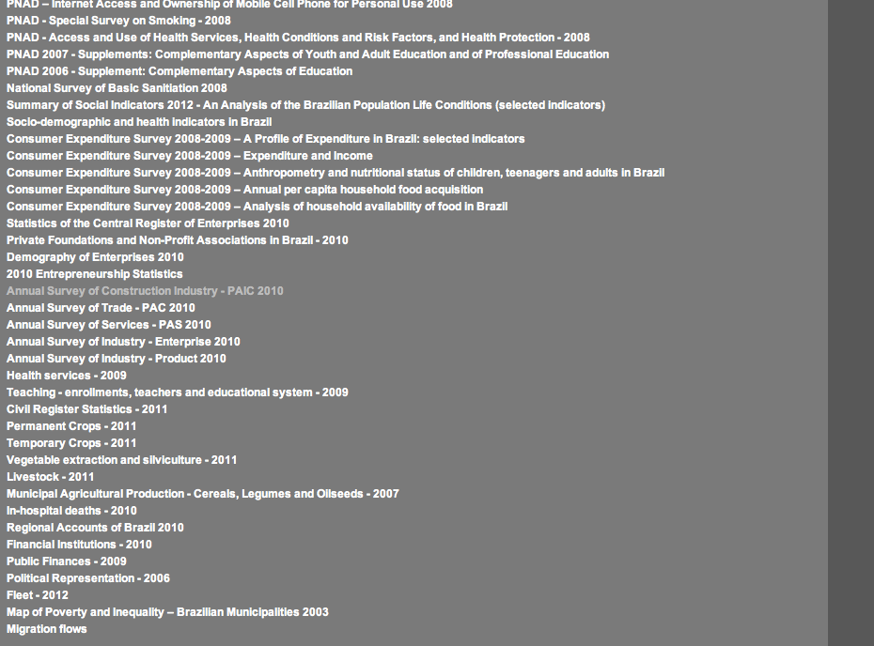
1. Click on ‘regional accounts of Brazil 2010’
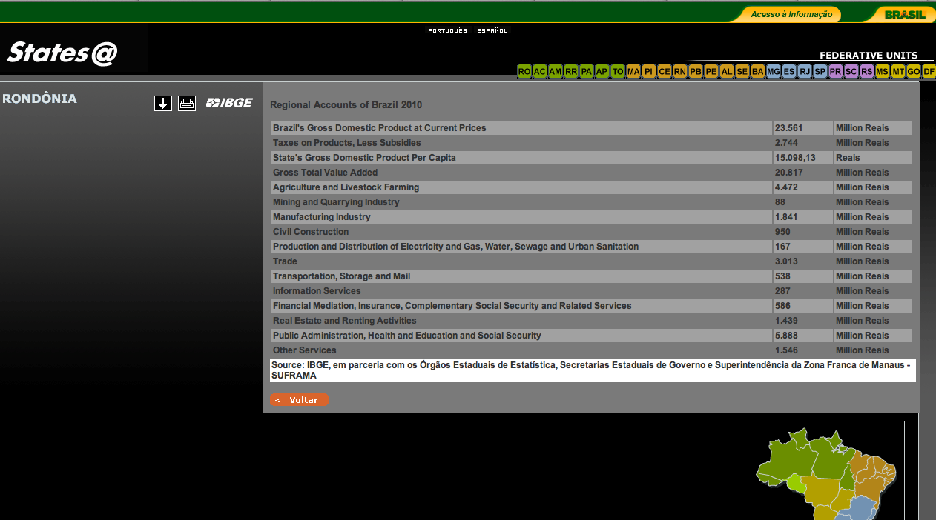
2. Get the figure for ‘State’s Gross Domestic Product per capita’.

- Scatter graph

Produce a scatter graph that shows GDP and population for each region.

Please ask the teacher for a piece of graph paper. You will be given instructions on how to draw and complete your scatter graph.

- Analysis

As the sales manager you are looking for people to sell cars to when they are finished. So you want a region with a high population density, but with high income per head.

- Look at the scatter graph and identify which area has the highest GDP and population.
- Which area has the highest population?
- Which area has the highest GDP?

Write an analysis that describes which areas have the highest/lowest population and highest/lowest GDP. Explain where you would locate your factory and why.

Use the writing frame below to help you.
Writing frame/sentence starters

The table shows…

The areas with the highest/lowest GDP/population density…

The scatter graph shows…

As the sales manager, I would choose the following region…

The reason why I would choose this region is because...

Vocabulary:

Sales manager
Population density
GDP
Region
State

