How much power should a King have?

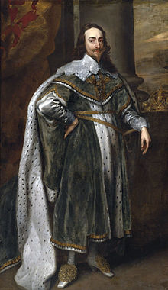
This is Charles I of England.

Rules of the game
- You MUST make a decision for each question, skipping questions is not allowed!

- The decision you take is up to you, but it must try to do as many of the following things as possible;
1. Keep control of your Kingdom
2. Keep the Kingdom calm and peaceful
3. Keep the Kingdom rich!

1. You have fallen in love! Unfortunately it appears to be with a French Catholic. There are rumours that she is having influence over you and might even be turning you into a Catholic (England was a Protestant country).
What should you do?
I choose option …
Because…

2. Parliament has not aided you in raising money and paying taxes. They suggest, in 1628, that they will give you some cash if you agree to some of their demands.
What should you do?
I choose option ...
Because...

3. Parliament has been nothing but disappointing to you. They have spread rumour and gossip and not helped you out when you needed it- You are the King!
What should you do?
I choose option ...
Because...

4. You have financial problems again and Parliament is not around to help. You decide to introduce a new tax- ship money. This was to be paid by entire towns. Ship money was a tax just on coastal towns supposedly to build defensive warships. It was intensely unpopular. What should you do?
I choose option ...
Because…

5. Your mate the Archbishop of Canterbury wants to introduce a new prayer book in Scotland. The Scottish are not so keen.
What should you do?
I choose option …
Because...

6. The Scottish are not happy. Infact, they've invaded! They have occupied parts of Northern England and won't budge until Charles gives in and pays them to go away. Charles is broke however- he needs parliament back! Parliament states it will only agree if you execute some of your advisors! What should you do?
I choose option ...
Because...

7. Those pesky Parliamentarians are just never satisfied! You executed your advisor chums and they still want to make more demands! They want a Parliament called every three years, control on tax increases and the King's right to dismiss them removed!
What should you do?
I choose option …
Because...

8. Some of your MP's escaped when you tried to arrest them! They appear to be raising an army to revolt against you. It might not be too late!
What should you do??
I choose option …
Because...

The Answers
You have 10 crowns to start with. Where you lose crowns, just delete them.
When you gain crowns, use Copy/Paste to add them!
Be honest!

