The Nature of Truth

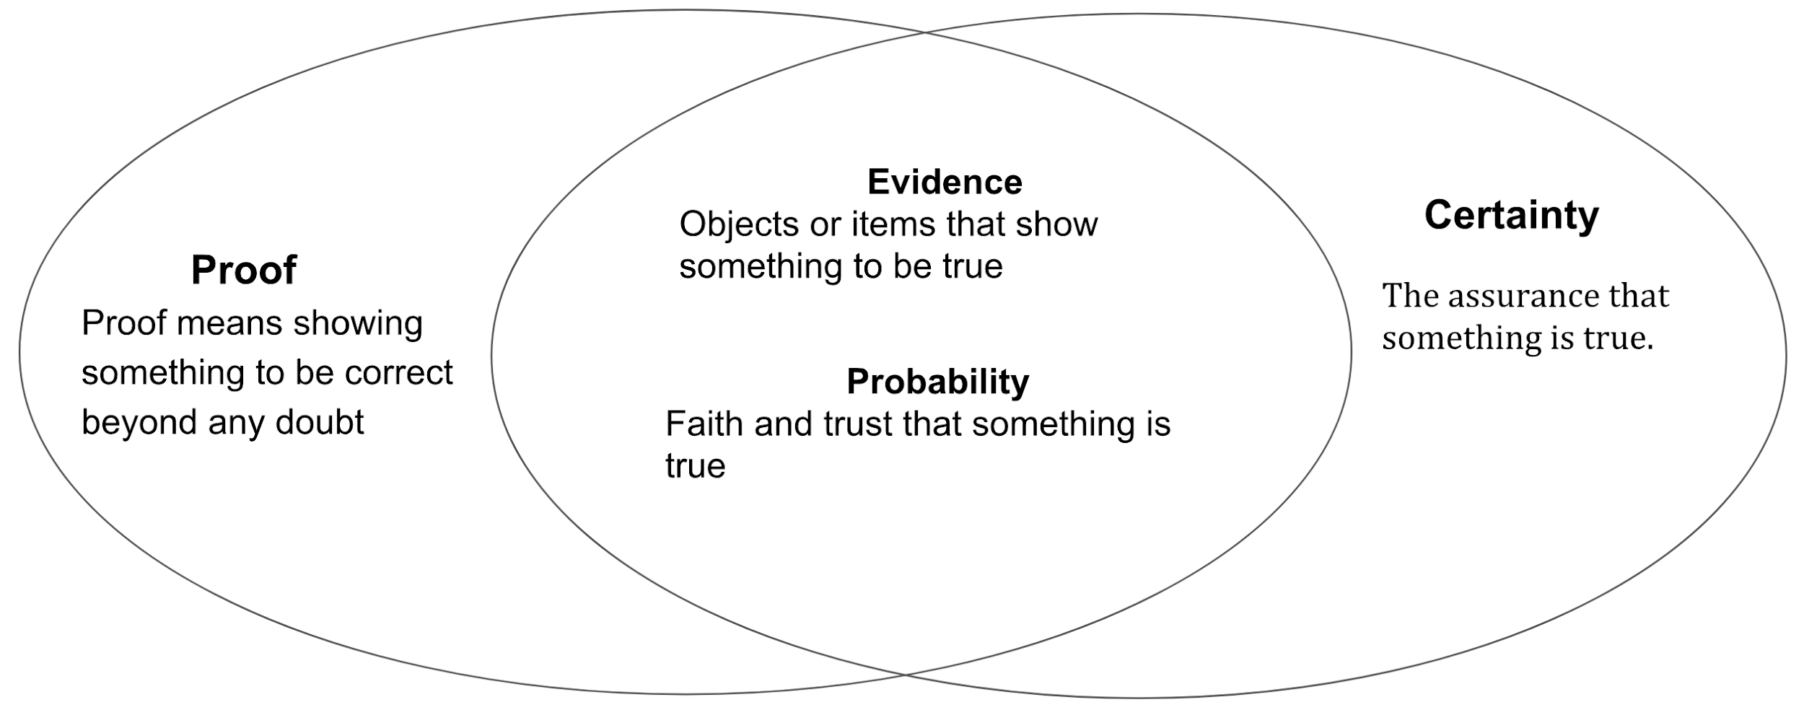

Innocent until proven guilty  I saw it therefore it happened  Seeing is believing  I heard from a trusted friend  These people love each other  We are going to die  I just know it’s true  God loves us | Everyone believes it’s true  The death penalty is wrong  Earth’s climate is changing  The world is flat  Trees are green  Dreams predict the future  We live in a computer simulation

What is truth?

Scientific Truth
This is concerned with the way the universe and everything in it works, and is based on empirical evidence. Scientists;
-Observe something in the world using the senses, and record it, e.g. Newton observed apples falling down from trees
-Form a hypothesis or theory
-Carry out experiments to see if the hypothesis stands up to repeated testing
-Conclude that something is true
However, there are limitations to scientific truth. It is liable to change with new observations and it can be falsified. Scientists may make mistaken judgements due to flawed experiments, intellectual limitations or unconscious bias. So scientific truth is not the absolute truth that some people think it is. Theories remain theories and are dependant on belief.

Historical Truth
People often assume that historians simply collect facts and then state what happened. It is not as simple as that! Historians rely on a variety of sources;
-Archaeological
-Documentary
-Eyewitness evidence
-Personal letters and diaries
-Film and Photographs
Again, there may be problems. The evidence may be only partial or have been tampered with. Crucial pieces of evidence may be missing, and written sources might be the product of bias or propaganda. The historian has to interpret events.

Moral Truth
Moral truth is different from scientific and historical truth, as there is no empirical evidence that may be used. It is based on abstract reasoning (Thinking through a point of view logically). Many people also rely on the views of religious teachers. For example, Jesus’s Golden Rule was that you should treat others as you would wish to be treated. Variants of this rule are found in all religions. Moral philosophers also give us guidance.

Moral truth is based on the dictates of an individual’s conscience. Conscience may be thought of as an inbuilt guide to what is right and wrong, as ‘a message from heaven’, or as something that is formed by the way we are brought up, by our education and by our psychological development.

Some people believe that moral truth is absolute; if something is right then it is always right, whatever the situation or culture. They may rely on principles such as the ten commandments or on rules of their society. Others, however, take a more relative approach and believe that what is right depends on the situation. For example, according to situation ethics the only thing that matters is doing what is most loving in each situation.

There are problems, then, with moral truth. With the absolutist approach, how do we know which principles are right? In some situations an inflexible application of rules does not seem to make sense. Relative approaches, in contrast, run the risk of being highly subjective. Abstract reasoning is not always easy and emotions play a part in thinking.

Spiritual Truth
Like moral truth, this is not based on empirical evidence but is about belief. Some base their beliefs on abstract reasoning, but others say spiritual truth is non-rational. It cannot be proved by reason, but relies on faith and trust. Those who believe that conscience is the voice of God speaking to them see that as a guide to spiritual truth.

Religion | Sacred Text | Religious Authority | Religious Experience
Buddhism | Tipitaka | Bhikkhu, Dalai Lama | Meditation
Christianity | Bible | Priest, Pope | Prayer, Sacraments
Islam | Qur’an | Imam, Qadi | Salah
Judaism | Tenakh | Rabbi, Beth din | Prayer

There are problems with spiritual truth. Many people think it cannot be trusted because it is subjective and based on individual experience. How do we know religious books contain the truth? How do we know we can trust religious leaders, especially when some do not practice what they preach? Why should be believe someone who says they have a vision? They might have imagined it. It all comes down to trust. Some people say that if you would normally trust what they says, then you would have no reason to doubt a vision was experienced if a person says so. Nor should they doubt themselves if they have no reason to doubt the experience was genuine. Others judge the validity of spiritual truth on the effects it has on a person's life. What is important is not its basis, but its results.

