Trial by Ordeal - God Decides!
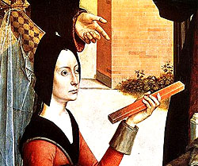
Ordeal by Fire
This ordeal was often used for women. This was where a person would be made to carry an iron bar that had been heated in a fire until it was glowing red hot. The distance they would have to carry the bar would usually be 3 metres. The person's hands would then be bandaged. The court would wait for three days, after which the bandages would be taken off the person's hands. The hands would be inspected by a priest. If the hands were still burned (let’s be honest, the most likely outcome here) the person was deemed to be guilty.
It was assumed that if the person was innocent, God would have intervened and healed the hands. Presumably it takes God three days to heal burned hands.

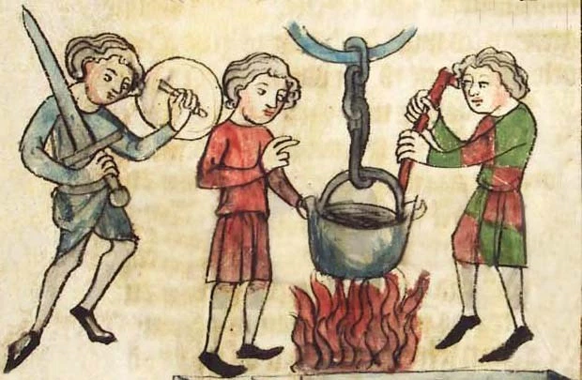
Ordeal by Water

The ordeal of hot water requires the accused to dip his hand in a container of boiling water and retrieve a stone.

King Athelstan of England made a law concerning the ordeal. The water had to be about boiling, and the depth from which the stone had to be retrieved was up to the wrist for one accusation and up to the elbow for three. The ordeal would take place in the church, with several in attendance, purified and praying God to reveal the truth. Afterwards, the hand was bound and examined after three days to see whether it was healing or festering.

This was still a practice of 12th-century Catholic churches. A suspect would place his hand in the boiling water. If after three days God had not healed his wounds, the suspect was guilty of the crime.

An early example of the test was described by Gregory of Tours in the late 6th century. He describes how a Catholic saint, Hyacinth, bested a rival by plucking a stone from a boiling cauldron. Gregory said that it took Hyacinth about an hour to complete the task (because the waters were bubbling so ferociously), but he was pleased to record that when the accused tried, he had the skin boiled off up to his elbow.

Trial by Cross
The ordeal of the cross was apparently introduced in the Early Middle Ages in an attempt to discourage judicial duels among the Germanic peoples. Unlike most other ordeals, the accuser had to undergo the ordeal together with the accused. They stood on either side of a cross and stretched out their hands horizontally. The one to first lower his arms lost.

Trial by Ingestion
This was a type of trial by ordeal that consisted of a suspected person eating a piece of barley bread and cheese totalling about an ounce in weight and blessed by a priest as a trial of his innocence. If guilty, it was supposed the bread would produce convulsions and paleness and cause choking. If innocent, it was believed the person could swallow it freely, and the bread would turn to nourishment.

Trial by Poison
Some cultures, such as the Efik Uburutu people of present-day Nigeria in the 1600s, would administer the poisonous Calabar bean in an attempt to detect guilt. A defendant who vomited up the bean was innocent. A defendant who became ill or died was considered guilty.
Residents of Madagascar could accuse one another of various crimes, including theft, Christianity, and especially witchcraft, for which the ordeal of poison was routinely used. In the 1820s, ingestion of the poisonous nut caused about 1,000 deaths annually. This average rose to around 3,000 annual deaths between 1828 and 1861.

